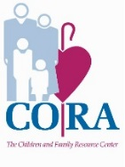
CORA Early Years Parent Gives a
Grateful Goodbye

How did you find CORA Early Years La Salle?
We saw the sign in front of the building near her doctor’s office when our daughter was around two years old. We realized that our daughter was eager to learn and socialize. To encourage her interest, we started the process of looking for a preschool that would stimulate her. From the minute I walked in the door, I could tell it had a caring culture. The staff showed genuine love for teaching and the kids. The teacher was an instant connection with my daughter, Journie. We knew it was the perfect place for her.

Over the past 2 years, how has Journie changed?
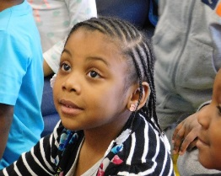
Journie is an outgoing child. She sings, make up songs, dances, and has learned to catch lightning bugs this summer. By attending CORA Early Years, she has grown into a very independent child. I am happy that CORA has encouraged our core values of teaching her to care about others. Most recently, Journie has developed a love of sign language.

CORA has taught her a variety of skills that has prepared her to go to kindergarten. After Journie finished testing for her new school, I brought her back to Early Years to show the teachers scores. They went WILD! They were so proud of her, they gave her big hugs and high fives.
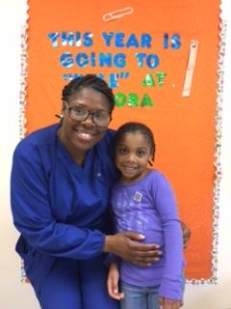
As a parent, how has CORA Early Years supported you?
While being a full time employee and part-time student CORA has supported me mentally, emotionally and spiritually. Not to mention they took care of my baby. When I completed my degree, I received a beautiful card from the entire staff with flowers and a poem. They helped Journie make a card for me and helped instill the importance of learning. They are 100% apart of the reason I was able to complete my associates degree in Human Services.

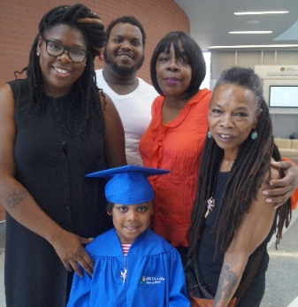
Working fulltime, going to school and raising Journie, has not always been easy. Some days there has been tears but it has built character in Journie that will last a life time. I am happy that she has join me in on my path to success. I am happy that CORA was here to support Journie on the beginning of path to success.

On graduation day, our family was so proud to see Journie walk on the stage to receive her preschool certificate. The CORA staff highlighted all the wonderful learning experiences including field trips, special guest speakers, and birthday celebrations. Watching Journie with her classmates use sign language as they sang the alphabet was so impressive. The curriculum at CORA has helped Journie to be prepared for kindergarten in so many ways. We will always be grateful to CORA Early Years program.

CORA Early Years is licensed through the Department of Human Services, accepts CCIS, and is a participant of the Keystone STARS program. To enroll, www.coraservices.org ~ Children are the Heart of the Matter ~

