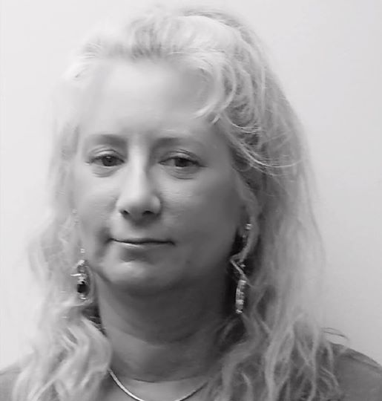

Laura Haertter

1108 First Ave

Croydon, PA 19021

(215) 378-4200
Summary:
My passion in life is to help others achieve the best quality of life possible, which is why I received a Master’s degree in Human Services. I enjoy working with diverse populations, where I can continue to grow my skills to improve the lives and circumstances of people, families and communities. I have a positive approach on everyday living. I am a cheerful person with much energy. I have personal and work experience with intellectual disabilities, fair hearings in Human Services due process, plus autism, advocacy and Waver Services.
Education:

Lincoln University Master of Arts in Human Services December- 2016
Lincoln University Bachelor of Science in Human Services December- 2015

Volunteer skills:

Pennsylvania Siblings Support Network Member 2011 to present
Vision for Equality -active participant 2005 to present
Have lobbied in Harrisburg many times for funding for disability services
Intern at SpArc services May 2014 to September 2014
Arc Alliance of Pennsylvania – active participant -Member 2007 to present
Participated in The Disability Policy seminar in Washington D.C. 2013

Employment:

Woods Services For Exceptional People October 2017 to May 2018
Family Living Provider /Respite January 2016 To May 2017
North Western Human Services April 2016 to May 2017
Pennsylvania Siblings Support Network - Philadelphia, PA January 2016 to January 2017
Sparkle Cleaning Owner/Operator 1986 to 2015

Trainings & Certificate

Smart Training October 2017
Communication October 2017
Smith Driving October 2017
Recognizing and Reporting Child Abuse July 2017
Older Adult Protective services/ Intake Worker training September 2017
Applied Behavioral Analysis October 2016
Adult and pediatric First Aid/CPR/AED September 2016
Conflict Resolution June 2014
Working with others: Interpersonal Communication July 2014

