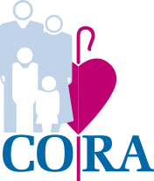

Dear Parents, Guardians, and Care-Givers,
CORA Early Years: La Salle is ecstatic to announce to you all, that as a high-quality program in our community, we have been selected by the School District of Philadelphia to participate in the FREE Pre-K Counts program! Starting this September, our Pre-School classes will both be transitioning to Pre-K Counts classrooms. We will work closely alongside our SDP partners to provide additional services and programs for the students in our center. This includes additional funding by the state to provide high quality classroom experiences for your children, as well as maintain and recruit additional highly qualified, credentialed, certified teachers and educators. This is a big step for our program, and we are so appreciative and thankful to YOU, the loyal families who have been with us, and made it possible for us to move into this next chapter. We are committed to providing you with all the information about the program as it is made available to us. In the interim, please find the attached FACT SHEET, which explains the Pre-K Counts program, and why it is such a special and successful program for pre-school aged children.
After reviewing the fact sheet, we invite you to bring any questions or concerns to management. I will be available in the coming weeks for phone conferences and in-person meetings by request. Please do not hesitate to reach out. We look forward to continuing to grow with you and your child, and we thank you for your continued support of our program!
Best,
Melody Dougherty, M. Ed.
Center Director
MDougherty@coraservices.org

