Samantha Jones
Philadelphia, PA. 19148
208.582.2653
samreamer1@gmail.com

September 19, 2018

Cora Services, Inc. -- Prevention Education Specialist

To whom it may concern:

I am seeking to apply for the position of Prevention Education Specialist. With my B.A. in Special Education and my Master’s in Social Work from the University of Chicago, I believe that I exemplify all of the qualifications and would be a credit to your organization. I recently graduated with my Master’s in Social Work from the poverty and inequality program of study. I completed two full year internships with social welfare organizations, along with training related to systemic oppression, counseling and case management, substance use, grant writing, community resource allocation, program monitoring and evaluation, etc.

I have dedicated all of my adult life toward making conditions for marginalized populations more equitable. I recently completed my second year internship at the Illinois Department of Children and Family Services, working on the Youth Housing Advocacy Program and the Family Unification Program. My work revolved around training outside partners for our youth programs, monitoring and evaluating their programs, answering case management questions and concerns, and assisting with the creation of intervention plans. I also secured adequate and stable housing for child welfare involved youth and families, as well as connected them with employment, community resources, continuing education, etc. I’m comfortable working on teams, collaborating with other organizations to serve the population in the most intersectional way possible, and coordinating and implementing activities and training geared toward learning and engagement. Prior to graduate school, I worked as a special educator, so I understand the need for family engagement early on, have a deep understanding of programs already made available, and can collect data and present it to families and staff in an understandable and meaningful way.

I am detail oriented, have strong written and oral language skills, am fully proficient in all Microsoft Office programs, and am a dedicated worker. I have experience across the board, from case management to evaluation. I look forward to discussing this more in person. You can reach me at samreamer1@gmail.com or at 208.582.2653. Thank you for your time and consideration.

Sincerely,
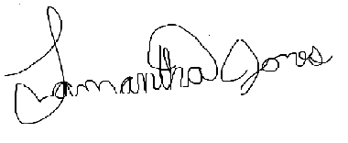
Samantha Jones

