Samuel C. Evans M.Ed., M.S.Ed.

Aspiring School Leader
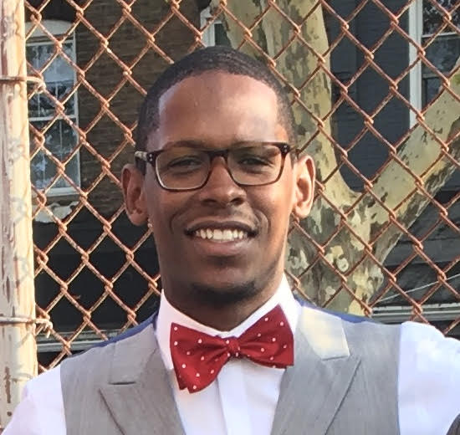
Fluent in Microsoft Office, including: Microsoft Outlook, Microsoft Word, Microsoft Works, Microsoft PowerPoint, and Microsoft Excel.
COMPUTER SKILLS
- School Culture/Climate
- Instructional Coaching
- Policy & Procedure Design
- Restorative Practices
- Funding/Budgeting
- Program Development
- Curriculum Development
- Community Relations
- Student Support Systems
- Facilities Management
- Staffing/Training

CORE COMPETENCIES
- 3 years of teaching exp. In Social Studies and S.E.L.
- 9 years of school leadership exp. as a Dean of Students, Director, and Assistant Principal.

CAREER DETAILS
PROFILE
As an energetic, results driven school leader with strong communication skills, I am wired to connect with scholars through building positive relationships. I have a vast set of skills and experiences in school turnaround and school design (i.e. building a school). I am drawn to educational organizations that have a clear purpose of impacting the lives of the scholars and families they serve.
- A lifelong learner committed to the social, emotional, and academic development of children.
- A learning leader that is committed to building teacher pedagogy through a culture of practice and collaborative support.

WORK EXPERIENCE

Ascend Learning Inc. Brooklyn, NY June 2018 – Present
Director of School Culture: Brooklyn Ascend High School

Belmont Charter Network, Philadelphia, PA Aug. 2017 – July 2018
Assistant Head of School: Belmont Charter High School

School District of Philadelphia, Philadelphia, PA Sept. 2016 – Aug. 2017
Director of School Culture and Climate: Frankford High School

Mastery Charter Schools, Philadelphia, PA Jan. 2011 – Sept. 2016
Advanced Dean of Students/SEL Instructor: Shoemaker Campus

VisionQuest, South Mountain, PA May 2009 – Jan. 2011
Principal/History Teacher: Boyer Academy

EDUCATION

UNIVERSITY OF PENNSYLVANIA, Philadelphia, PA July 2018
Masters of Science in Education: School Leadership
Public and Charter School Track w/ Principal Certification

ENDICOTT COLLEGE, Beverly, MA May 2009
Masters of Education: Sport Management
PreK-12 & Higher Education

ENDICOTT COLLEGE, Beverly, MA May 2007
Bachelors of History: Social Studies w/Minor in Education
Activities: Varsity Men’s Basketball Team & Resident Assistant

CERTIFICATION

PRINCIPAL CERTIFICATION Expected September 2018
Pennsylvania Department of Education, Public Schools
Secondary Schools

TEACHER CERTIFICATION, Certification in History Sept. 2010
Pennsylvania Department of Education, Private Schools
Secondary Schools

Glenside, PA

267-972-1108

samuelevans24@gmail.com

AREAS OF EXPERTISE
ADMINISTRATION
- Manage and monitor school-wide student service programs (e.g. Health Office, Lintons Food Services, PIAA, Outside Vendors, etc.)
- Disseminate and post weekly and monthly reports for scholars, teachers, and parents on school climate data (e.g. conduct referrals, level 2’s, merit and demerit cards, out-of-school suspensions, etc.)
- Supervise and monitor scholars during morning arrival, transitions, lunch, and dismissal.
- Collaboratively develop and manage the various school schedules (e.g. regular bell schedule, benchmark testing, orientation schedule, etc.)
- Collaboratively work in accordance with the leadership team to fulfill all school compliance requirements (e.g. title 1, emergency and safety, teacher certifications, etc.)
- Organize, implement, and administer a variety of standardized tests (e.g. Edmentum, Keystone, PSSA, etc.)
- Cooperatively work with the truancy office to align and monitor all attendance mandates, policy, and procedures from the School District Office and District Attorney’s Office.
- Collaboratively work in accordance with the Sped Coordinator to fulfill all special education law requirements (e.g. meetings with parents, evaluations, documentation, etc.)
ORGANIZATION MANAGEMENT
- Manage the school culture program budget of 15K (e.g. field-trips, community events, homeroom activities, merit mall, school-wide initiatives, etc.)
- Supervise, train, hire, and evaluate non-instructional staff (e.g. school counselor, deans, climate support staff, etc.)
- Monitor and maintain a safe school environment to ensure that all scholars’ social, emotional, and personal needs are met so they can maximize on all opportunities in the classroom.
- Manage and troubleshoot staff concerns (e.g. individual schedules, call-outs, lesson planning, observations, collegial conflict, etc.)
- Collaboratively work in accordance with the leadership team to hire certified instructional teachers across content areas.
INSTRUCTIONAL PROGRAM
- Plan and facilitate weekly professional development for faculty and staff (e.g. school climate, classroom management, lesson planning, instructional practices, content specific standards, etc.)
- Develop and assess educational programming across the school (e.g. content specific curriculums, career expedition week, summer school, after-school, intervention block, advisory, etc.)
DAY-T0-DAY INSTRUCTION/OPERATION
- Perform unannounced and frequent classroom observations and walk-throughs across content areas.
- Informally and formally evaluate teachers by providing instructional feedback in the moment and through formative and summative assessments.
- Create and co-facilitate instructional coaching plans and practice opportunities for teachers.
- Analyze various forms of instructional data to improve and enhance the pedagogical practices of teachers.
INTERNAL RELATIONS
- Consistently interact with faculty and staff about both school related and non-school topics (e.g. chat and chews, school committee meetings, one-to-ones, etc.)
- Communicate with scholars and parents to ensure that their voices are heard and a part of the schools decision making process.
EXTERNAL RELATIONS
- Collaborate with local community members and organizations to establish partnerships to ensure that the school is constantly evolving into a hub of support and family engagement.
- Establish various fundraising efforts to ensure sustainability of school activities and programs.

