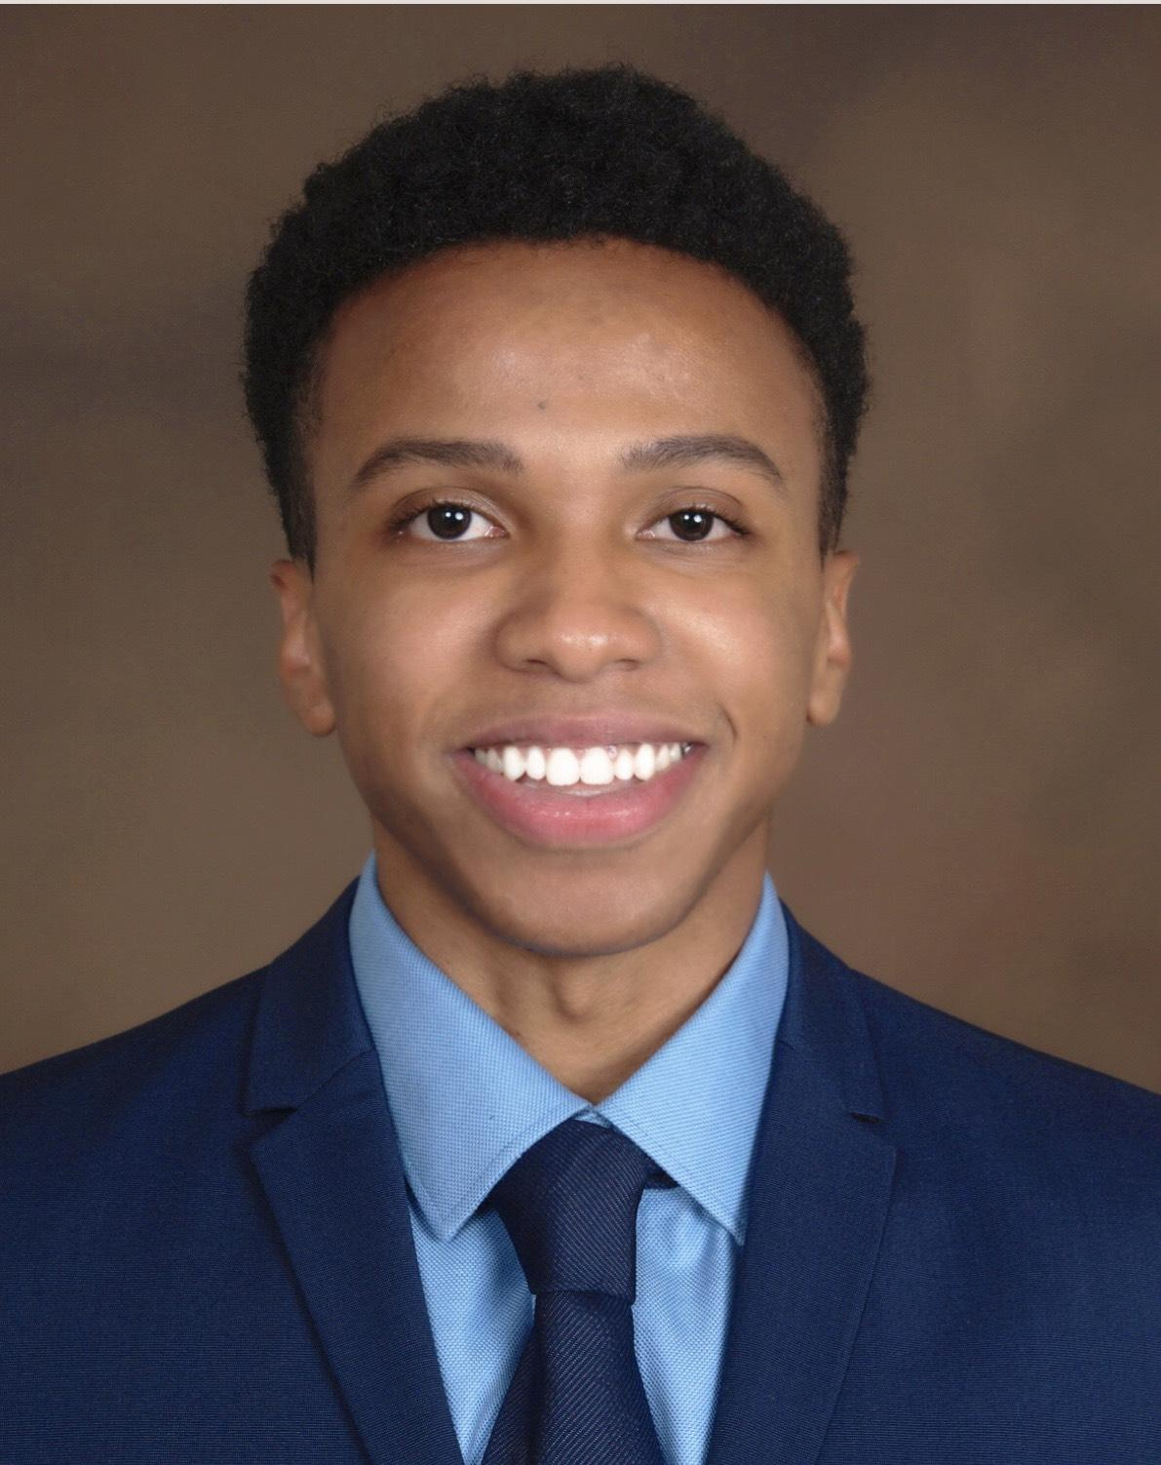

Jovanni  Goodman  Teacher/Counselor | Jovanni Goodman  267.647.4292  goodmanjovanni@gmail.com
ㅡ  Skills | Adapting curriculum by using my creativity to meet every student needs. Using a positive and energetic teaching style for learning needs engagement; academic; achievement; cognitive development; and improvements.
ㅡ  Experience | Bachelor Degree / 2016-2020  Education  Pennsylvania State University  - Member of HJS  - Generalist in Elementary Education (K-6)  - RHS ( Human Resources )
ㅡ  Skills | Skills  * Creativity  * Imaginative  * Communication  * Enthusiasm  * Positive Attitude  * Great at Decision Making
ㅡ  Experience | Cheltenham ; Myers Elementary CLASP ASSISTANT Teacher :  1/2018 - 2/2019  Sharon Rose Petals Christian Learning Center ; Teacher :  1/2014 - 1/2018  SRPCL Camp Counselor  5/2014 - 5/2018

ㅡ  Languages | English  Spanish

