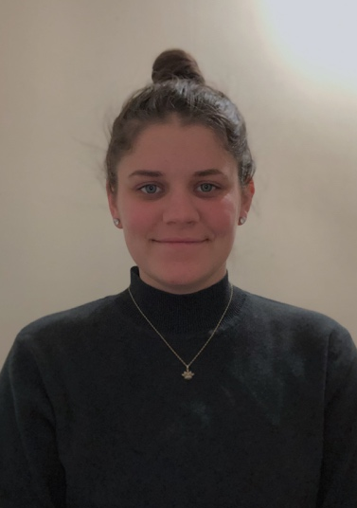
Katelyn
Colleran
OBJECTIVE  Teach elementary/special education students. Interested in coaching/advising and willing to relocate. Eager to continue education and would like to specialize in STEM.  ADDRESS  18 Welsh St  Pittston PA, 18640  United States  PHONE  (570)2372806  EMAIL  katelyn.colleran@gmail.com |  |  | EXPERIENCE
ESS Substitute Teacher--Current
Rupert Elementary School Building Substitute, Pottstown PA
As a building substitute, my duties include covering various teachers/assistants throughout Rupert Elementary, as well as, other elementary schools within the district. On days I do not have an assignment I assist the lead Emotional Support teacher in aiding her various students throughout the day. I check in with classroom teachers to see if there are any tasks they would like me complete whether it be grading tests or working with individual students. I have completed the PSSA training and have both administered the PSSA and worked as a scribe for a student taking the assessment.

Student Teaching Experience– Fall 2018
Washington Elementary, Boyertown, PA
I co-taught in a split schedule setting in a 4rd grade classroom while implementing lesson plans that I adapted to follow the Lucy Calkins Reading and Writing Units of Study along with Social Studies lessons that I developed myself. I practiced a lot of classroom management strategies and escorted students to different specials. I chose grade-appropriate books to read to the students for an end of the day read aloud. I worked closely with both teachers and student teachers that made up the 4th grade team and had ample of collaboration and team building experiences.

Student Teaching Experience– Fall 2018
Amanda E. Stout Elementary, Reading, PA
I co-taught 2nd and 3rd grade students in learning support and general education classrooms. I instructed students using McGraw Hill’s SRA Corrective Reading program. I developed lesson plans and activities to implement during small-group math; during this time, the students received SRA Connecting Math Concepts instruction from the classroom teachers. I attended IEP meetings and performed DIBELS Testing to all 2nd and 3rd grade students.

Professional Semester Student– Spring 2018
Cumru Elementary School, Reading, PA
I co-taught in a 3rd grade classroom while implementing my own lesson plans. I attended IEP meetings and escorted students to different specials. I participated in their Earth Day celebration by reading a story and allowing students to touch, smell, and feel different fruits and vegetables that are uncommon to their daily surroundings.
 |  | Education comes from within; you get it by struggle and effort and thought.  -Napoleon Hill  Education is a weapon whose effects depend on who holds it in his hands and at whom it is aimed.  -Joseph Stalin | Katelyn Colleran continued:  EXPERIENCE  Trio Student– Fall 2017  Amanda E. Stout Elementary, Reading, PA  I co-taught 3rd, 4th, and 5th grade students in learning support and general education classrooms. I implemented lesson plans, attended IEP meetings and performed DIBELS Testing on the students I worked with.
 |  |  | EDUCATION
Kutztown University, Kutztown, PA
B.S.ED. August 2016- December 2018
Major: Elementary Education and Special Education (MPH K-8)
GPA 3.4

Alvernia University, Reading, PA
B.S.ED. August 2014- May 2016
Major: Elementary Education and Special Education (MPH K-8)
GPA 3.2

 |  |  | Honors/ campus involvement
- Fall 2017—Winter 2019 Phi Sigma Pi—National Society of Leaderiship and Success
- Fall 2016-2018, Spring 2018 Dean’s List at Kutztown University
- Fall 2014, Spring 2016 Dean’s List at Alvernia University
- Spring 2017-Winter 2019 Phi Sigma Sigma, member
 |  |  | Skills
 |  |  | Due to my unique experiences given to me while attending both universities, I have developed skills such as good communication and collaboration skills, co-teaching and organization. I am also able to develop and implement unique lesson plans as well as adapted lesson plans. I practiced supporting students’ needs through by offering push-in/pull-out learning support services to identified students. I have practice in performing DIBELS Testing on students and can successfully implement McGraw Hill’s SRA Corrective Reading Program.

