M/K | 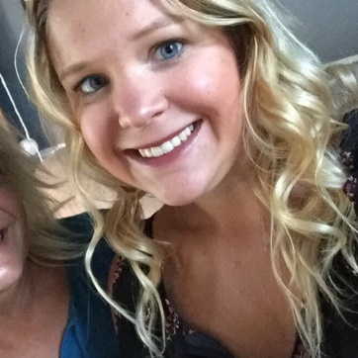  Morgan Kretzinger
OBJECTIVE  To obtain a position as a school/guidance counselor in a school setting.  ADDRESS  1700 Stanwood St  Philadelphia, PA, 19152  PHONE  215-840-8234  EMAIL  Morgankret92@gmail.com  WEBSITE  www.linkedin.com/in/morgankretzinger629/   |  |  | EXPERIENCE
October 2019- November 2019
Family Connections Liaison • Catapult Learning
March 2o19– March 2020
Substitute Teacher • Mariana Bracetti Academy Charter School

January 2018- April 2018
Internship Student • Northeast High School
August 2017– December 2017
Internship Student • Crossan Elementary School
January 2017 - April 2017
Practicum Student • Farrell Elementary School

- Support students while doing assigned school work
- Establish and enforce the school rules and policies while in the classroom
- Guide and counsel students who need academic and behavioral help
- Collaborate with other teachers and staff members
- Facilitate small counseling groups
- Design and deliver classroom guidance lessons
- Individual counseling
- Analyze attendance reports
- Attend and participate in IEP and 504 team meetings
- Professional phone calls to parents and community agencies
- Observation of students
- Prepare students for college and career readiness
 |  |  | EDUCATION
Gwynedd Mercy University, Philadelphia, PA
Masters of Science in School Counseling
Graduated: September 23, 2018
GPA: 3.86, Praxis score: 165/200

Holy Family University
Bachelors of Arts and Sciences in Psychology
Graduated: May 2015
 |  |  | CERTIFICATIONS
K-12 Professional School Counselor
Mediating and Permissive Reporting in Pennsylvania
Protecting Human Research Participant
 |  |  | LEADERSHIP
American School Counselor Association-Member
Psi Chi National Honor Society for Psychology

TRAININGS
Promote Safety, Inclusion and Well-Being for LGBTQ Students
Youth Suicide Prevention
Prepare Students for the Transition Out of High School
Behavior Intervention Plans for Tier 3 Students
Effective and engaging Curriculum Lesson Planning
Improve School Culture, Prevent Bullying
 |  |  | REFERENCES
 |  |  | [Available upon request.]

