
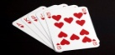
Math Games Using A Deck of Cards
Give your flash cards a rest and practice facts with math card games instead. Simply lay down two cards from the deck (remove the face cards first) and add, subtract, or multiply them. Kids can work on this alone, or you can make it a contest to see who can call out the correct answer first.
Flash Card Dash
Tape a series of flashcards to the floor and challenge kids to see who can correctly make their way from start to finish the fastest. They can call out the answers or write them down, but they have to get it right before they move on. Kids can race side by side, or work independently to beat their own best time.
Bowling with Math
Set up empty plastic bottles labeled one through 10, then roll the ball to see how many you can knock down. Add up the numbers of the knocked-over bottles to get your score.
Guess the Number Game
Build number sense by writing numbers on your child’s back.
Then, have them guess the number or vice versa.
Paper Plate Clock
Review time using a paper plate Supplies needed: paper plate straw and markers. Cut the straw to make the hour and minute hands. Write the numbers going around the plate and have fun telling time!
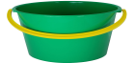

Beach Ball Addition or Multiplication
Supplies needed: Beach ball and Permanent marker
Instructions: Label a beach ball with numbers 1-12 (make sure to repeat numbers for practice adding doubles). Have your children toss the ball to each other or to you. Before they can pass it on to the next person, they simply add whatever numbers are under their hands after they catch it.
Hopscotch math
Game 1- This game is a great way to get your child outside on a nice sunny day. Using a piece of chalk, draw a hopscotch grid on the pavement mimicking a calculator layout. Give them a simple operation (e.g. 2+3, 5–0). Have you child hop on each element of the equation in the correct order, landing finally on the answer.
Game 2-In another game, you can call out a number and ask your child to hop on any equation that equals to that number. For a fun twist, ask your child to hop on one leg for odd numbers, and two legs for even numbers.
Sidewalk Chalk Math  Have your child draw a basic flower with 10 numbered petals as shown. Then they write a number to multiply (or add or subtract) by in the middle, and fill in the petals with the correct answers. | 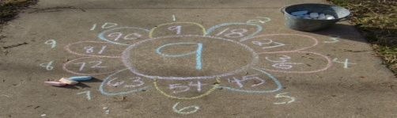
Math in the Sand
Say math problems verbally and have your child write her answer in the sand
Shell Math
Collect shells and count them one-by-one for small groups of numbers, or group the shells by tens to count larger numbers.

