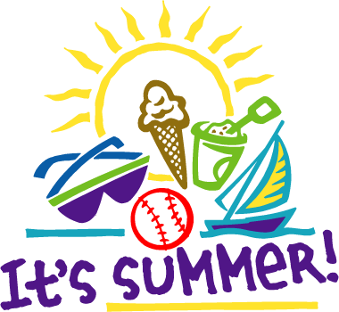SUMMER READING ACTIVITIES FOR STUDENTS IN GRADES 4, 5, AND 6

- Read a book and watch a movie about it. Compare and contrast the two, using a Venn diagram.
- Create a game of multiple meaning words using index cards or tag board to play with a friend or family member at a summer outing or on a rainy day. Write a contextual clue sentence to match each meaning of the word. E.g.; The dog will bark loudly when he sees the mailman. The bark of the tree is decaying.
- Test your skill while having fun playing literacy games such as Scrabble, Sequence, Trivia Pursuit, and Boggle. Don’t forget crossword puzzles and word searches.
- Write step-by-step instructions for an activity of your choice for someone who will be doing it for the first time. You may want to consider a recipe for a favorite food, a sport, a science experiment, arts and crafts projects, STEAM activities, gardening, or others.
- Keep a journal of your experiences during the Coronavirus pandemic. How have you and your family been affected? Describe how your routines have changed since the school closures. Evaluate your life and learning before and after this historic event. State your preferences. Provide details to support your position.
- Take a (virtual) tour of historic and/or cultural sites in the Philadelphia area, or to a destination of your choice. Create a travel journal to describe and summarize your experience at each site you visit. You can begin your expedition with the following links. Explore zoos in Cincinnati at Facebook Live safari, the Elmwood Park Zoo in Norristown at https://www.facebook.com/EPZoo/, https://zoo.sandiegozoo.org/live-cams, or https://www.facebook.com/pg/philadelphiazoo/videos/. Go under the sea with Australia’s The Nature Conservatory’s Reef Cam. Travel to Paris, France to see works of art at The Louvre . Visit the Boston Children’s Museum, the Monterey Bay Aquarium In California, or take a Virtual Tour of the Great Wall of China. FarmFood 360 offers 11 virtual tours of farms.
- Celebrate July 4th/Independence Day with the resources in numbers 8-14 below.
- Perform readers theater - https://www.teacherspayteachers.com/FreeDownload/Declaration-of-Independence-Readers-Theater-FREEBIE-2638248.
- Watch 1) films – a) 1776 The Musical - excerpts from the 1972 film version of the musical & b) the independence episode of the TV miniseries John Adams; and 2) videos - July 4th (The History Channel) - 12 brief videos and 4 photo galleries.
- See school children recite The Declaration of Independence in "Plain" English (Bigley ... How would you rephrase the document in words easy to understand?
- Read along with well-known actors in this video clip of reading the Declaration. The script is the text of the original document.

Sing with PBS Kids Yankee Doodle Dandy Kidsongs | Part 1 | Patriotic....Find lyrics at https://www.songsforteaching.com/holiday/4thofjulyindependencedaysongs.htm.
- Test your wit and that of others as you make and play word games with these templates: https://myvocabulary.com/word-game-puzzles/july-4th-vocabulary/.
- Visit Independence National Historical Park.. Earn prizes as you successfully complete activities at https://www.nps.gov/inde/learn/kidsyouth/jrrangerchallenge.htm (and other national parks across America.)
- Write a poem, song, story or skit about a special summer activity.

We hope you and your family have a wonderful summer!

