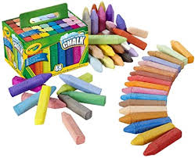
- Visit storylineonline.net to hear a children’s book read aloud to you by your favorite actor, actress, or sports star!
- Write a review for a favorite TV show, board game, or video game.
- Using sidewalk chalk, illustrate a scene from a story that you read with your child
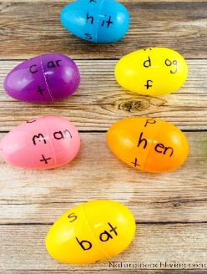
- Read the book Green Eggs and Ham together – and enjoy a breakfast of green eggs (with food dye!)
- Create a “book nook” – a fun place to cozy up and read – with pillows, a bean bag, etc.!
- Rewrite the words to a favorite song to describe a book, character, or the plot of a story.
- Make a Phonics “Flipbook” with a wire-bound index card book.
- Use plastic Easter eggs to create “word families.”
- Go to sightwords.com to enter in your student’s sight word lists – and create various games that use them…like Snakes and Ladders!
- Write sight words in sidewalk chalk.
- Create a “Summer Reading Bingo Board,” listing the names of age-appropriate books for your student. The first one to read all their books to get a BINGO wins a prize! (An ice cream treat or picking the movie for family movie night are fun prizes for kids!)
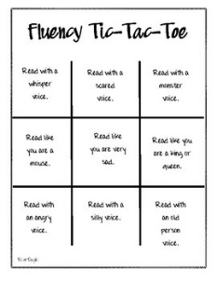
- Create an “Inference in a Bag” activity! Place an object in a brown paper bag. Have students use their inferring skills to ask questions such as “Who might use this item?,” “What shape is the item?,” “What does the item smell like?” to guess what is inside!
- Write a postcard to a friend or family member!
- “Noun Hunt:” create a list with all of the letters of the alphabet – have your child search the house for nouns that begin with each letter!
- Go on a “Haiku Hike” at a local park or in your neighborhood – take field notes throughout the hike about what you see, hear, and feel – be as descriptive as possible! Capture a moment in time or a scene in nature, then write a haiku about it and draw a picture.
- Create a newsletter about your summer – writing about vacations you’ve been on, places you’ve gone, or people you’ve seen! Mail it to a friend or relative!
- Make a “summer scrapbook” filled with postcards and photos of your summer! Write captions underneath!
- Play “Fluency Tic-Tac-Toe” where you create a tic-tac-toe board to read a passage three or more times in different voices. Label each box with a fun reading style like “Read with a whisper voice,” “Read with a pirate’s voice,” “Read with a monster voice,” etc.!
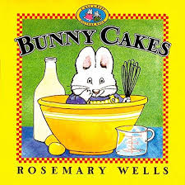
- Create a “Mystery Box” with an item inside. Have your student write three clues/sentences describing the object inside. Have friends or family try to guess what is inside based on your descriptive writing!
- Use Play-Doh, sand, or shaving cream and a wooden skewer (to act as a pencil) to have your student write out sight words!
- Visit your local library – sign up for a Library card or borrow a book!
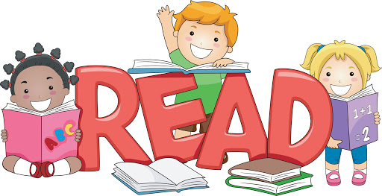
- Read the book Bunny Cakes and then work with your child to follow a recipe to make a cake, and then decorate it like the character in the story.
- When in doubt, read aloud! Snuggle up with a good book with your child and enjoy reading together – whether it’s on the porch, in a park, or at the beach!

